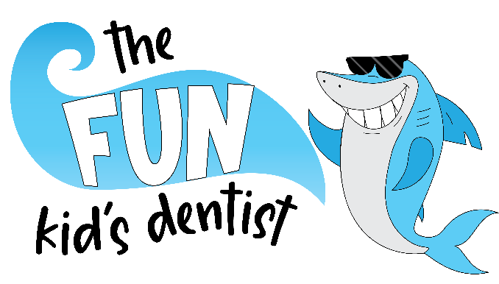**Financial Policy**

We are committed to providing you with the highest quality of care. Our fees reflect the quality of care we provide. In order to provide your child with the highest level of care, we are out of network with all insurances. This ensures that we can treat your child’s needs based on our doctors’ recommendations and not dictated by insurance companies. We understand that dental treatment can be an investment, therefore we continue our commitment by offering a variety of financial options to enable you to receive the dental care you need. We accept cash, check, VISA, MasterCard, Discover and American Express. Returned checks will result in a $30 processing fee. We have also partnered with a third-party company, CareCredit, to offer the flexibility of deferred interest and extended payment options. Please see carecredit.com for more information. Payment is due at the time of treatment.

We will communicate all recommended treatment options and associated fees, prior to the start of treatment. As a courtesy, we will forward a pre-authorization for treatment to your insurance company. A deposit of 10% is due at the time of scheduling, and 40% is due at the time of treatment. If we have received a pre-authorization back from your insurance company, we will collect that co-pay at treatment, in lieu of the 40%. While we are not in network with your insurance company, we will submit claims on your behalf in a timely manner. However, it is ultimately your responsibility to be familiar with your insurance benefits. A delinquent account impedes our ability to provide you with the quality dental care that you deserve. It is our policy that the parent or guardian who accompanies a child to our office for treatment is responsible for payment of all services rendered.

**Important Facts About Dental Insurance**

* Dental insurance is a contract between the patient/subscriber and the insurance company. It is a benefit to assist you with the cost of dental care. Insurance benefits should never dictate your doctor’s diagnosis or affect your choice of treatment.
* It is your responsibility to understand the type of dental insurance you have (example: Traditional, PPO, DMO) and the benefits selected by you and/or your employer.
* **You** (not the insurance company) are responsible for the fees of services rendered. Should your insurance fail to remit payment for services rendered within 90 days from the date of service, you are responsible for the full cost of treatment.
* We are not in-network nor do we have a contract with your insurance company. While many insurance companies have out of network benefits, we do not anticipate 100% coverage for procedures.
* As a courtesy to keep you informed, accounts with an outstanding balance will receive a statement every 30 days, regardless of pending insurance.
* Payment is expected at the time of service. We accept 10% to reserve appointment, with 40% or pre-auth amount collected at time of service.
* Payment plan for self-pay or co-pay amounts: 50% at time of service, 25% in 30 days, and 25% in 60 days with credit card stored on file.
* Should insurance pay over the expected amount, a refund will be made to you within 2 weeks of the overpayment.
* We reserve the right to send delinquent accounts to an outside collection agency.